**Experiment 2.3**

**Student Name:** Nabha Varshney **UID:** 20BCS4995

**Branch:** B.E.-CSE  **Section/Group:** 20BCS704-A

**Semester:** 6th **Date of Performance:** 11/04/2023

**Subject Name:** Internet of Things Lab **Subject Code:** 20CSP-358

1. **Aim:**

#### To display data generated by sensor on LCD using Arduino/Raspberry Pi.

1. **Objective:**

* Learn about interfacing.
* Learn about IoT programming.

1. **Requirements:**

* 1 x Raspberry Pi3 Model B`s with installed Raspbian
* 1 x LCD 16x2
* 1 x Arduino

1. **Procedure:**

#### **About LCD**

A Liquid Crystal Display commonly abbreviated as LCD is basically a display unit built using Liquid Crystal technology. When we build real life/real world electronics based projects, we need a medium/device to display output values and messages. The most basic form of electronic display available is seven segment display, which has its own limitations. The next best available option is Liquid Crystal Displays which comes in different size specifications. Out of all available LCD modules in market, the most commonly used one is 16×2 LCD Module which can display 32 ASCII characters in 2 lines (16 characters in 1 line). Other commonly used LCD displays are 20×4 Character LCD, Nokia 5110 LCD module, 128×64 Graphical LCD Display and 2.4 inch TFT Touch screen LCD display.

#### **Interfacing  16×2 LCD to Arduino uno**

LCD modules form a very important part in many arduino based embedded system designs. So the knowledge on interfacing LCD module to arduino is very essential in designing embedded systems. This section of the article is about interfacing an Arduino to 16×2 LCD. JHD162A is the LCD module used here. JHD162A is a 16×2 LCD module based on the HD44780 driver from Hitachi. The JHD162A has 16 pins and can be operated in 4-bit mode (using only 4 data lines) or 8-bit mode (using all 8 data lines). Here we are using the LCD module in 4-bit mode. First, I will show you how to display a plain text messages on the LCD module using arduino and then  I have designed a useful project using LCD and

### arduino – a digital thermometer. Before going in to the details of the project, let’s have a look at the JHD162A LCD module.

#### **16×2 LCD Module Pin Out Diagram**

The JHD162A lcd module has 16 pins and can be operated in 4-bit mode or 8-bit mode. Here we are using the LCD module in 4-bit mode. Before going in to the details of the project, let’s have a look at the JHD162A LCD module.The schematic of a JHD162A LCD pin diagram is given below.

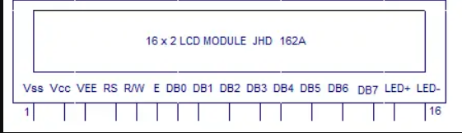

1. **Code/Program:**

#include <LiquidCrystal_I2C.h>

//included the library of I2C LCD

LiquidCrystal_I2C lcd(0x27, 16, 2);

//declared the I2C LCD

void setup(){

lcd.setCursor(0,0);

lcd.init();

//used the built-in function of keypad library function to initialize the LCD

lcd.backlight();

//turn on the backlight of LCD

lcd.print("HELLO CU");

// print on the LCD

}

void loop(){

}

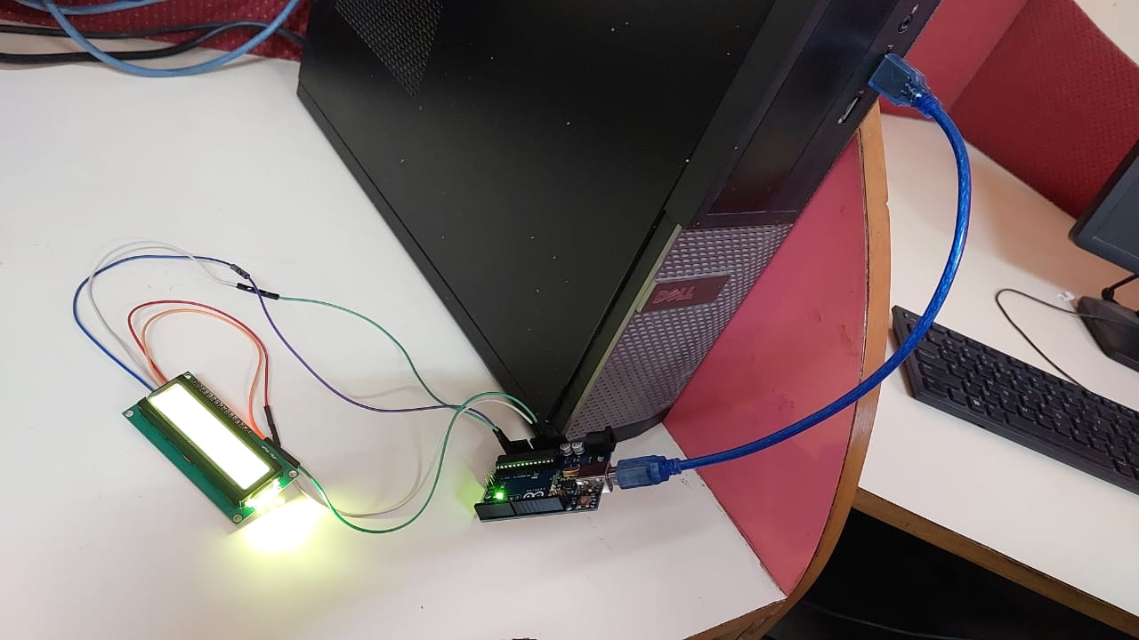

**FIGURE: Circuit**

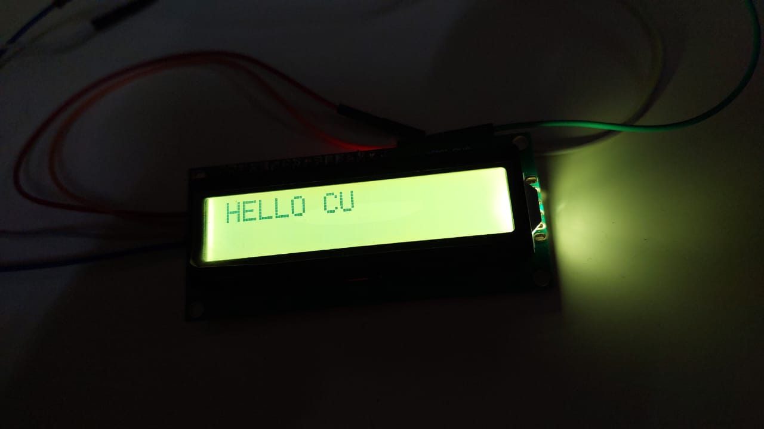

**FIGURE: Output**

**Result-**

In this experiment we learn how to display data generated by sensor on LCD using Arduino. And we display various text on the LCD.

**Learning outcomes (What I have learnt):**

* Learnt how to use LCD to display the data using Arduino.
* Learnt how to code to read the data from the sensor.